Ans 1.

Network 10.145.14.128/26

Mask : 255.255.255.192

Router Configuration.

IP : 10.145.14.191

Workstation IP Config:

IP Range: Anything in 10.145.14.129-10.145.14.190

Subnet ID : 10.145.14.128

Broadcast address: 10.145.14.191

Ans. 2

|  |  |  |
| --- | --- | --- |
| Order | Step | Explanation |
| 1 | DHCP traffic to request an IP address | This provides an IP address to our system and gets the IP address of our DNS Server |
| 2 | DNS type MX request for gwu.edu | This is to mail exchanger information from root. |
| 3 | DNS type A request for iron3-mx.tops.gwu.edu | This is to get IP address of a mail exchanger defined in root. |
| 4 | ARP request for the gateway's IP | To resolve IP address of mail address to connect to it outside the network. |
| 5 | TCP SYN packet sent to the IP of iron3-mx.tops.gwu.edu | To setup a TCP connection to Mail Exchanger using 3 way handshake. |
| 6 | SMTP MAIL command to the IP of iron3-mx.tops.gwu.edu | To send a mail via mail exchanger. |

Ans3.

Step1.

whois president.az

Output : This TLD has no whois server, but you can access the whois database at

|  |  |
| --- | --- |
| http | //www.nic.az/ |

Step2.

nslookup president.az

Server: 161.253.152.241

Address: 161.253.152.241#53

Non-authoritative answer:

Name: president.az

Address: 31.170.237.115

Step3.

whois 31.170.237.115

% Information related to '31.170.232.0 - 31.170.239.255'

% Abuse contact for '31.170.232.0 - 31.170.239.255' is 'atesh@delta-telecom.net'

inetnum: 31.170.232.0 - 31.170.239.255

netname: DELTA-WIMAX

descr: DELTA Wimax Network

country: AZ

admin-c: RA907-RIPE

tech-c: EK1287-RIPE

status: ASSIGNED PA

mnt-by: MNT-DELTA-TEL

mnt-lower: MNT-DELTA-TEL

mnt-routes: MNT-DELTA-TEL

created: 2012-11-27T15:49:42Z

last-modified: 2012-11-27T15:49:42Z

source: RIPE # Filtered

person: Elvin Kelenterov

address: 241 Sharifzadeh str

address: Baku, AZ1012

address: Azerbaijan Republic

phone: +99412 4311420

phone: +99412 4040478

phone: +99450 2058570

fax-no: +99412 4310065

abuse-mailbox: abuse@delta-telecom.net

nic-hdl: EK1287-RIPE

remarks: Technical contact Delta Telecom LTD

mnt-by: MNT-DELTA-TEL

created: 2006-04-15T08:21:53Z

last-modified: 2010-07-02T04:13:29Z

source: RIPE # Filtered

person: Rahid Alekberli

address: Baku, AZ1012

phone: +994 12 404 12 12

nic-hdl: RA907-RIPE

mnt-by: MNT-DELTA-TEL

created: 2003-03-03T10:29:45Z

last-modified: 2013-12-16T12:38:35Z

source: RIPE # Filtered

% Information related to '31.170.224.0/19AS29049'

route: 31.170.224.0/19

descr: Delta Telecom IP Range

descr: International Communication Operator

origin: AS29049

mnt-by: MNT-DELTA-TEL

created: 2011-04-01T04:22:53Z

last-modified: 2011-04-01T04:22:53Z

source: RIPE # Filtered

% This query was served by the RIPE Database Query Service version 1.82 (DB-4)

Ans 3.a Name and Contact Information of owner of the Domain

person: Rahid Alekberli

address: Baku, AZ1012

phone: +994 12 404 12 12

nic-hdl: RA907-RIPE

mnt-by: MNT-DELTA-TEL

created: 2003-03-03T10:29:45Z

last-modified: 2013-12-16T12:38:35Z

source: RIPE # Filtered

Ans 3.b: IP Address of [www.president.az](http://www.president.az) : 31.170.237.115

Ans 3.c: Size of the allocation where ip address resides is **31.170.232.0** - **31.170.239.255**

Ans 3.d: Name and Contact Information of the Owner of IP Address Space:

Organization that owns the IP address space is Delta telecom network ltd.

Name and Contact info of the Contact Person

person: Elvin Kelenterov

address: 241 Sharifzadeh str

address: Baku, AZ1012

address: Azerbaijan Republic

phone: +99412 4311420

phone: +99412 4040478

phone: +99450 2058570

fax-no: +99412 4310065

abuse-mailbox: abuse@delta-telecom.net

nic-hdl: EK1287-RIPE

remarks: Technical contact Delta Telecom LTD

mnt-by: MNT-DELTA-TEL

created: 2006-04-15T08:21:53Z

last-modified: 2010-07-02T04:13:29Z

source: RIPE # Filtered

Ans 3.e :

Using online traceroute:

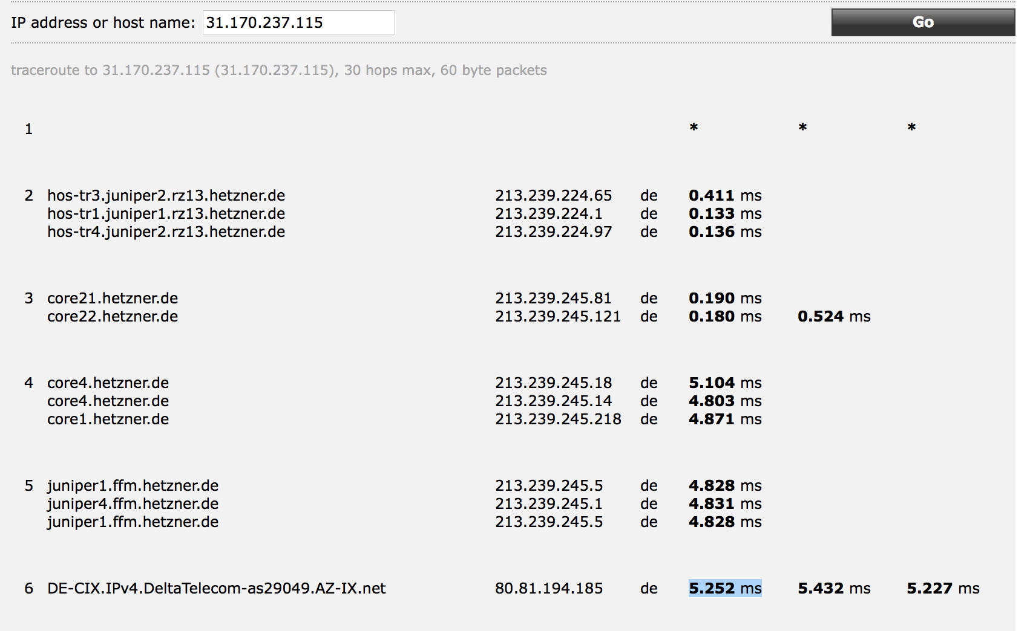

So Delta Telecom is an ISP provider to the IP address

Using traceroute on terminal

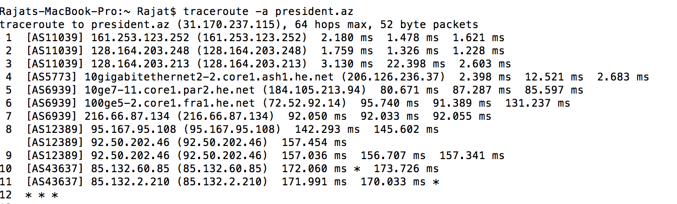

So 10gigabitethernet2-2.core1.ash1.he.net is one upstream ISP providing internet connectivity.

Ans 4. Yes, the MX record for gwu.edu is different than the MX record for seas.gwu.edu. It implies that since gwu.edu is root for seas.gwu.edu, which is having multiple exchange servers as opposed to the single exchange server for seas.gwu.edu.

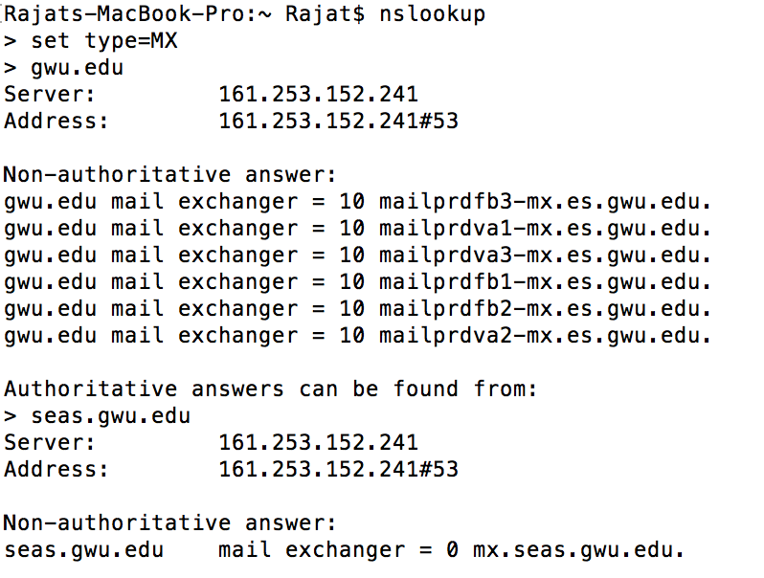

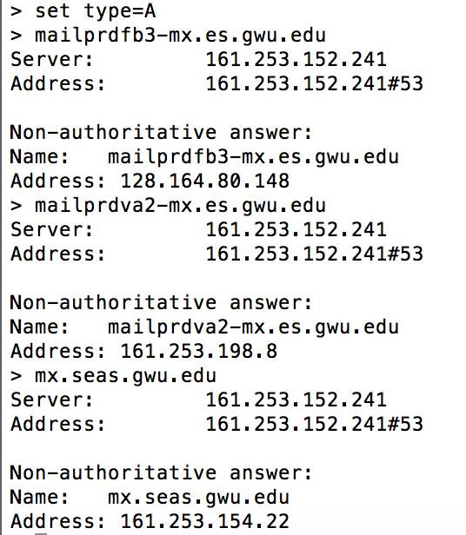

I did whois for mx.seas.gwu.edu(161.253.154.22) and got CIDR as 161.253.0.0/16.

This implies that mx.seas.gwu.edu(161.253.154.22) is in same network as mailprdva*-mx.es.gwu.edu(161.253.198.8 for va2)(Virginia Campus), but in a different network than mailprdfb*-mx.es.gwu.edu(128.164.80.148 for fb3)(Foggy Bottom Campus)